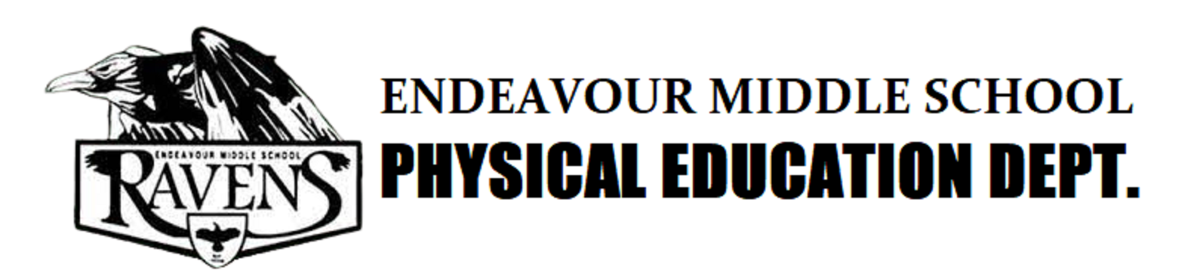

**Physical Education Syllabus 2023-2024**

**DESCRIPTION**

This course will focus on teaching students to be prepared, work cooperatively to achieve a common goal, meet challenges, make decisions, and problem solve. Students will demonstrate ability to follow directions as well as knowledge of physical fitness concepts, principles, and strategies to improve their overall health and performance.

**PHYSICAL EDUCATION UNIFORM**

* **School Uniform** – This year students will receive 1 free PE uniform set. Students who lose or misplace their PE clothes may purchase replacements through the PE department. Shirts: $10, Shorts: $10, Sweatpants $20, and Hooded Pullover Sweatshirts $20. We also offer an optional Sports Bag for sale for $5 (the bag will not be included with the set.)
* **Alternate Uniform** - Students may bring an alternate PE uniform from home. Alternate uniforms must be a plain gray or black. T- Shirts must have a crew neck, we do not allow V- neck or U-necks as during certain activities such as push-ups they reveal more than what is allowed at school. (NO PRE-PRINTED LOGOS OR WRITING LARGER THAN A HALF DOLLAR).  Sweatpants and sweatshirts can be black or gray again with NO LOGOS OR WRITING LARGER THAN A HALF DOLLAR. For safety reasons, NO JACKETS or anything with zippers or buttons are to be worn out to PE as they may cause injury during activity. Sweatshirts must be pullover in style, they may have hoods attached if you wish but are not required.We recommend first and last name should be written at least 2 inches in height across the lower part of the t-shirt/sweatshirt and on the left thigh of shorts or sweatpants.  This will help to recover lost or misplaced clothing.
* **Footwear** - Athletic type socks and shoes are also required and must be laced up and tied properly to help prevent injury- NO BOOTS, SANDALS, SLIP-ONS, CROCS or CROC LIKE SHOES, ETC. Students may keep a pair of PE shoes in their locker if they wish.
* **Jewelry, cell phones, and backpacks** may NOT be brought out to P.E., they should be locked up in the students provided locker. Cell phones that are confiscated will need to be picked up by parent in the office.
* **Care for Uniforms** - Students are responsible for keeping uniforms clean. They should be taken home at the end of the week to be washed and brought back at the beginning of the following week

**DRESSING OUT**

Living in the desert we will experience both hot and cold weather, this is not a reason to not dress out. Students must be prepared with both warm and cold weather PE clothes as described above. Students will have approximately 7 minutes at the beginning of the period and 7 minutes at the end of the period to dress out. Disciplinary action will be taken if dressing out becomes an issue. Students are to report immediately to their assigned number and sit down. **Nondress students will only be allowed in the locker room to lock up their backpack and must leave immediately when done, going directly to their class number & sit/squat.**

* **Dressing out** is essential to any PE related class. Students are expected to dress out every day for activity. Students should be prepared for both hot and cold weather and bring deodorant (stick or roll-on only) for use after class (SPRAYS/AIROSOLES ARE **NOT** ALLOWED AT SCHOOL AND WILL BE CONFINSCATED).
* **Over Dressing** (putting your PE clothes on over your regular school clothes) will be counted as a nondress for the day and nondress penalties will apply.
* **Parent notes** – Parents can excuse students from participation for 1-3 days due to sickness or injury, but students will still be required to dress out.
* **Doctor notes** - Only students with a written excuse from a Doctor will not be required to dress out. Doctors notes are only valid for 1-month max, they must have a return to PE date or next doctors visit date within 1 month, if the student still needs to be out a new doctors note must be submitted.
* **Students that cannot participate** in class due to a note will be given an alternate activity/make up assignment for the duration of the excuse.

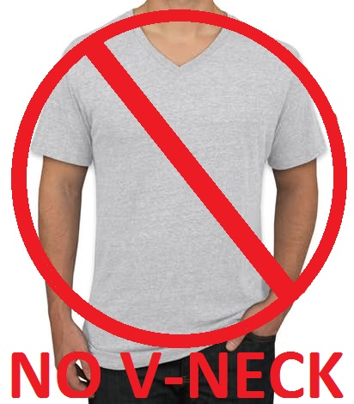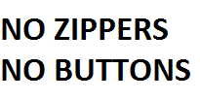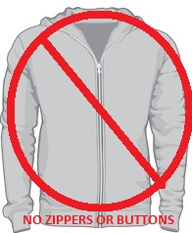

Dressing Out Means:

* Tennis Shoes, Shorts or Sweatpants, T-shirt (crew neck only, no V-necks) or sweatshirt

Dressing Out **Does NOT** mean

* Jeans, Jean shorts, Khakis, Skirts, Board Shorts, or anything of that nature.
* Jackets (anything with a zipper or buttons)
* Flip-Flops, Sandals, Boots, Crocs or Croc like shoes, etc…
* Tank tops, V-Necks, Halters, etc…**School Dress Code still apply**
* No Jewelry is to be worn out to P.E. (i.e. bracelets, necklaces, earrings, etc.)

**LOCKERS/LOCKER ROOMS**

Students will be assigned to a locker (locks will be provided) to use for the school year. A fee of $8 will be charged to students who lose/damage their locks. **NO LOCKS FROM HOME ARE ALLOWED**. Endeavour’s PE department reserves the right to cut off any lock brought from home. The PE department is not responsible for lost or stolen items. Students may NOT share lockers and should not give out their combinations. Students must make sure to lock their lockers to prevent theft. No glass items are allowed in the locker room (i.e. cologne, perfume, drinks, etc.)

**ABSENCES/TARDIES**

* **Tardies** – Students who are tardy to class will lose points. Chronic tardies will be met with further disciplinary action.
* **Absences** - Students will lose participation points when they are absent from class. A make-up assignment on google classroom and/or a one-page hand written report on anything sport/nutrition related can be turned in to earn these points back, 1 page for each day a student is absent.

**EXPECTATIONS/ NORMS**

* Students will be respectful to themselves, all peers, staff, and PE equipment.
* Students will be sitting/squatting on their number until class begins.
* Horseplay, play fighting, cursing and obscenities will not be tolerated.
* Students will come to class with a positive attitude and ready to be active.
* Students must be in proper dress code for PE (dressed out).
* No Cell phones are to be brought out to PE.
* Students must not leave PE area until the bell rings.
* No food or drinks allowed in the PE areas, except water. (No frozen water bottles)

(Waters and Chewy bars will be sold after PE and are not to be eaten or drank inside the locker room.)

**CONTACT INFORMATION**

Main Office (661) 943-8270

Girls P.E. ext 518 Boys P.E. ext 517

Coach Gridler [gridlerj@lancsd.org](mailto:gridlerj@lancsd.org) Coach Gonzales [gonzalesd@lancsd.org](mailto:gonzalesd@lancsd.org)

Coach Fleming [flemingn@lancasd.org](mailto:flemingn@lancasd.org), Coach Robinson [robinsonx@lancsd.org](mailto:robinsonx@lancsd.org)

-------------------------------------------------------------Cut Here------------------------------------------------------------------

I have received, read and understand the Endeavour Middle School physical education syllabus.

_______________________________________ _______________________________________

Student’s Name Printed Parent’s/Guardian’s Signature